

Nursing, Midwifery and Allied Health Professions
(NMAHP) Development Framework

Development Needs Analysis Tool (DNAT)
Level 8 – Consultant Practitioner
Getting Started
The Development Needs Analysis Tool (DNAT) is designed to help you reflect on your current job role and identify areas where further training, education, and development could enhance or advance your skills.
Upon completion of the DNAT, you will have a list of specific knowledge, skills, and behaviours (KSBs) you wish to develop, along with evidence statements to support your competence. If you have additional KSBs, university modules, or competency statements to include, there is a blank section for this purpose.

For full guidance and to access the blank DNAT, please visit the Access the Framework section of the website, select your level, and then choose the DNAT link/dropdown.

Sign Off
This tool is designed to support you in your appraisal and Personal Development Review (PDPR) process, while also providing evidence of your ongoing continued professional development (CPD). There is a Sign Off template at the end of the tool to enable this.

Select a Pillar to review
You can complete all the pillars at once or individually, there is no set order for this.

Self-assessment of Knowledge Skills and Behaviour (KSB) Statements
Rate yourself using the RAG rating scale. Give careful thought to your assessment and how you might demonstrate proficiency of the KSBs.

RED
I require training and development in most or all of this area.

AMBER
I require further training and development in some aspects of this area.

GREEN
I am already confident in carrying out this outcome competently.

As you assess yourself, consider how you might demonstrate proficiency and provide evidence. Your thoughtful evaluation will help guide your development plan. There is an Action Planning and Priority Rating Tool that you may find helpful to support you.

Evidence
If you have rated yourself as having a development need in this area (red or amber), make a brief action note on “how” you would anticipate meeting this development need and any evidence you may already have. This might be detailing what you are going to do, what actions you might need to take, how you are going to do this and when. You may find the action plan template helpful with this.
You need to provide evidence for amber and green ratings only.
The evidence should be clear and concise and relevant to the KSB demonstrating proficiency in the area of practice. It should contain detail of the relevant learning and how this is applied in your practice. Evidence can be sourced from many areas of your practice like a reflection, training undertaken, supervised practice, reflective discussion/clinical supervision activity, feedback from colleagues and/or service users, reports.
For more guidance on evidence go to Access the framework section of the website and select your level and then the DNAT drop down.


DEVELOPMENT NEEDS ANALYSIS TOOL - LEVEL 8
Please review the knowledge, skills and behaviour statement and rate yourself using the RAG rating scale. Give careful thought to your assessment and how you might demonstrate proficiency of the knowledge, skills, and behaviours.
Red | I require training and development in most or all of this area
Amber | I require further training and development in some aspects of this area
Green | I am already confident in carrying out this outcome competently
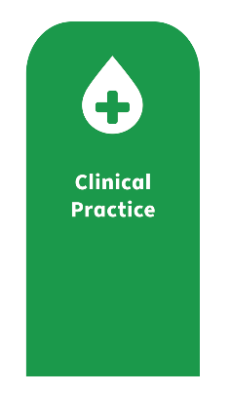
Knowledge, skills, behaviours | RAG rating |  |  | Evidence to support achievement | How you will achieve this outcome
Generic | Red | Amber | Green
8C1 - Use a wide range of skills and strategies, including a significant range of advanced or specialist skills, to communicate with people on complex matters or in complex situations supporting people in making decisions.
8C2 - Act as a champion and role model for values-based, person centred care and professionalism.
8C3 - Innovate, develop and role model safe, effective and person-centred practice. Within own area of practice and within the scope of the profession and individual scope of practice.
8C4 - Influence and contribute to the development of guidance and legislation that governs the legal and ethical aspects of service provision.
8C5 - Use expert knowledge of professional regulation and codes of practice and legislation to lead the development, implementation and evaluation of protocols guidelines and policies at operational and strategic levels.
8C6 - Use clinical data to drive improvement through review and interdisciplinary collaboration.
8C7 - Promote, monitor and maintain best practice in health, safety and security in accordance with health and safety legislation and infection control policies. Where appropriate lead on development/implementation and manage risk appropriately.
8C8 - Act on concerns and/or report serious incidents in line with local reporting procedures.
8C9 - Model and apply expert level critical thinking and evaluation skills to make timely and informed clinical decisions related to all aspects of the care process utilising professional judgement to manage risk appropriately.
8C10 - Contribute to the development and/or implementation of health related technology, digital and information systems to inform and improve health outcomes.
8C11 - Provide and share complex information effectively and concisely for a range of situations and contexts to ensure safety and continuity of care and act on professional judgement about when to seek help.
8C12 - Develop a culture that promotes equality, values diversity and protects people from discrimination.
8C13 - Develop innovative ways to promote health and well-being, improve health literacy and empower patients to share decision making and ensure person centred approach.
8C14 - Lead on the promotion, development and application of expert clinical knowledge, skills and behaviours appropriate to own area of practice and the wider service
8C15 - Recognise the effects and potential symptoms of trauma or vicarious trauma and respond appropriately. Practising at a minimum of Trauma Informed practice level.
8C16 - Ability to escalate concerns if unable to carry out duty and responsibilities outlined within health and care staffing legislation. Practising at Enhanced level.

You may wish to add additional KSBs from other profession specific or role specific frameworks relevant to your role. Below is a blank template for you to cut and paste these into.

Knowledge, skills, behaviours | RAG rating |  |  | Evidence to support achievement | How you will achieve this outcome
Role or profession specific competencies/KSBs | Red | Amber | Green |  | Red

Please review the knowledge, skills and behaviour statement and rate yourself using the RAG rating scale. Give careful thought to your assessment and how you might demonstrate proficiency of the knowledge, skills, and behaviours.
Red | I require training and development in most or all of this area
Amber | I require further training and development in some aspects of this area
Green | I am already confident in carrying out this outcome competently

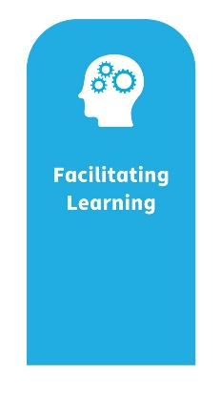

Knowledge, skills, behaviours | RAG Rating |  |  | Evidence to support achievement | How you will achieve this outcome
Generic | Red | Amber | Green
8F1 - Role model exemplary facilitation and teaching skills and develop those skills in others. Promoting a culture of excellence in learning to inspire existing and future staff.
8F2 - Demonstrate a critical understanding of the key theories of adult learning and apply a wide range of facilitation, teaching and assessment skills to practice.
8F3 - Lead on strategies that enable effective reflective practice
8F4 - Influence and implement organisational learning and development strategy in partnership with key stakeholders.
8F5 - Ability to effectively apply practice supervision, applying quality standards to facilitate pre and post registration learners to develop knowledge, skills and proficiency, using appropriate assessment criterion and quality standards to assess competence within own scope of practice.
8F6 - Evaluate, develop, lead and facilitate use of education materials for students, staff and service users at a regional and national level
8F7 - Work in close partnership with HEI and education providers to lead and contribute to curriculum development and delivery.
8F8 - Create opportunities for motivating others to learn and develop their teaching and assessment skills across the organisation.
8F9 - Lead on the promotion, development and application of expert knowledge of adult learning appropriate to own role at a local and national level.
8F10 - Design, develop and lead on educational audit and other feedback to plan and lead change at a local and national level.
8F11 - Design, develop and lead on educational audit and other feedback to plan and lead change at a local and national level to enable a positive learning environment.
8F12 - Develop, lead and support teaching, supervision and assessment skills in others
8F13 - Enact the Health and Care Staffing legislation to ensure there is adequate time provision to support the learning and development of workforce/team.
8F14 - Ability to engage in [clinical] supervision, using reflective practice and feedback to develop the quality of care and outcomes through:
- personal development and wellbeing; developing awareness and management of self
- continual professional development, with a focus on professional codes and quality standards
development of knowledge, skills and proficiency for practice
8F15 - Ability to effectively undertake the role of [clinical] supervisor for all functions of clinical supervision, within own scope of practice
8F16 - Use leadership skills to empower and enable others to engage in meaningful clinical supervision and use feedback to improve the quality of care

You may wish to add additional KSBs from other profession specific or role specific frameworks relevant to your role. Below is a blank template for you to cut and paste these into.
Knowledge, skills, behaviours | RAG Rating |  |  | Evidence to support achievement | How you will achieve this outcome
Role or profession specific competencies/KSBs | Red | Amber | Green

Please review the knowledge, skills and behaviour statement and rate yourself using the RAG rating scale. Give careful thought to your assessment and how you might demonstrate proficiency of the knowledge, skills, and behaviours.
Red | I require training and development in most or all of this area
Amber | I require further training and development in some aspects of this area
Green | I am already confident in carrying out this outcome competently
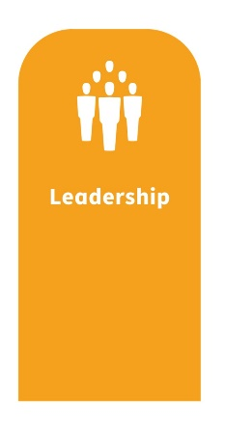
Knowledge, skills, behaviours | RAG Rating |  |  | Evidence to support achievement | How you will achieve this outcome
Generic | Red | Amber | Green
8L1 - Evidence leadership skills and behaviours that have a positive impact across organisations and broadening sphere of influence working at local and national level
8L2 - Communicate effectively at a strategic level through presentations, reports and policies to demonstrate organisational leadership.
8L3 - Embed the use of feedback in organisational learning policies.
8L4 - Demonstrate expertise in developing original and creative solutions to highly complex problems.
8L5 - Demonstrate organisational learning from concerns raised or escalated.
8L6 - Build and lead teams, develop effective relationships, ensure clarity of roles and work in collaboration with others at local and national level.
8L7 - Promote a culture where people are managed effectively using organisational policies and exemplary leadership qualities.
8L8 - Lead the development of the workforce in alignment with national priorities.
8L9 - Provide strategic direction to profession within board including organisational professional governance.
8L10 - Critically apply advanced clinical expertise and role model the values of NHS Scotland to influence the sharing and adoption of best practice, reduce unwarranted variation and enhance quality.
8L11 - Act a source of expertise in relation to clinical supervision, influencing organisational responsibilities in relation to clinical supervision as an essential professional development process
8L12 - Empower and inspire those in supervision roles to demonstrate a positive workplace culture that is kind, compassionate, diverse, and inclusive.
You may wish to add additional KSBs from other profession specific or role specific frameworks relevant to your role. Below is a blank template for you to cut and paste these into.
Knowledge, skills, behaviours | RAG Rating |  |  | Evidence to support achievement | How you will achieve this outcome
Role or profession specific competencies/KSBs | Red | Amber | Green

Please review the knowledge, skills and behaviour statement and rate yourself using the RAG rating scale. Give careful thought to your assessment and how you might demonstrate proficiency of the knowledge, skills, and behaviours.
Red | I require training and development in most or all of this area
Amber | I require further training and development in some aspects of this area
Green | I am already confident in carrying out this outcome competently

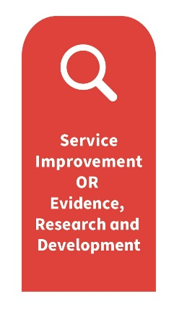
Knowledge, skills, behaviours | RAG Rating |  |  | Evidence to support achievement | How you will achieve this outcome
Generic | Red | Amber | Green
8E1 - Demonstrate a critical understanding of different research approaches, methods and analysis and support others to develop and apply these in practice.
8E2 - Lead by example and develop the capability of others to critically appraise and synthesize evidence to inform practice and create a culture in which audit, research and quality improvement thrives.
8E3 - Lead by example and develop a supportive culture to promote the sharing of good practice and lessons learned from audit, research and quality improvement activity locally and nationally through professional and peer reviewed processes.
8E4 - Use highly specialised theoretical and practical knowledge to develop original and creative solutions to problems and assist others to do so.
8E5 - Ensure self and others are able to use a wide range of Quality Improvement/Clinical Audit/Research skills and actively contribute to Quality Improvement, Audit or Research projects to inform and enhance practice.
8E6 - Apply a consistent and integrated approach to critical analysis, evaluation and synthesis of new and complex ideas, information, research data, statistics and issues and help others do the same.
8E7 - Lead and commission projects and encourage involvement of all staff.
8E8 - Take strategic responsibility to develop, revise and embed research governance including Good Clinical Practice[1], ethics, data protection and confidentiality in practice and promotes a strong research culture at service and organisational levels.
8E9 - Lead on the promotion, development and application of research and development appropriate to own role and the wider service
You may wish to add additional KSBs from other profession specific or role specific frameworks relevant to your role. Below is a blank template for you to cut and paste these into.
Knowledge, skills, behaviours | RAG Rating |  |  | Evidence to support achievement | How you will achieve this outcome
Role or profession specific competencies/KSBs | Red | Amber | Green

Action planning and priority rating

You should now take some time to reflect on your learning needs assessment and complete the action planning and priority rating tool to assist you in planning and prioritising your development.

It can also be helpful to discuss your learning and development needs with your line manager or practice assessor and update your personal development plan (PDP).

Pillar of Practice | KSBs  Code  (e.g. 8C4) | Action of “how” to achieve this KSB | Support required within Practice | Time Frames

Sign off
Name | Date of review | Comments
Sign off
Name | Date | Job title
Name | Date | Job title
Name | Date | Job title

